Resurrection of Our Lord Parish Council
Submitted by Parish President Viola Tobin

In November 2022 we made the decision to once come together and reactivate our Council, to give the next generation a chance to be part of an incredible organization. We have added new members, our total at present are 23 strong. We have one member receiving her 60 year pin and two receiving the Maple Leaf Pin for going above and beyond.
We are finding our way, mixing our more experienced members with our new. We are a work in progress; trying on new roles to see what feels right; exploring each other’s strengths; exploring the different avenues, to discover where our energy is most beneficial in our community.
In the past several months we have held a bake sale, the proceeds of which were distributed among: a youth going to World Youth Day; our Parish and our Council. Bags of baked goods were given to seniors; a cognitively challenged man; a prayer group who were meeting that evening at our parish and a couple of families with small children. We have held a successful food drive for the Ottawa Food Bank. We are continually offering Rosary/Divine Mercy kits, containing prayer cards and Rosary beads; prayer cards and pamphlets pertaining to the Eucharist and the importance of the Mass. We are now preparing for a Rummage sale at the end of April; A clergy Appreciation Dinner and a morning retreat in May concerning Faith; Forgiveness and Family.
Truly inspired by our Pope Francis we will try to live by his message for 2023:
“To deepen our knowledge of the Master, to fully understand and embrace the mystery of His salvation, accomplished in total self-giving inspired by love.” Spreading the Love of God to all humanity; by way of sharing; educating; freely giving; prayer; understanding and treating all with respect and dignity.
Our members are involved in different ministries in our parish; we visit the sick and shut ins; we bring Communion to those who cannot get to mass due to illness.

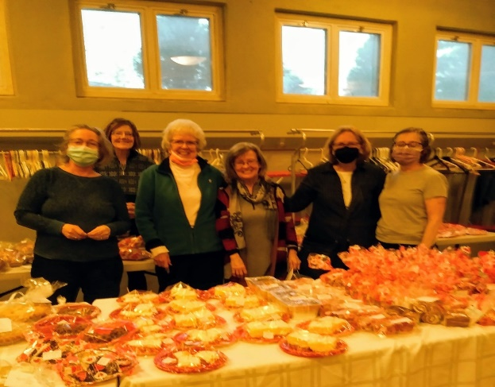
WE MADE A DIFFERENCE
Our parish and our Council at our successful bake sale.

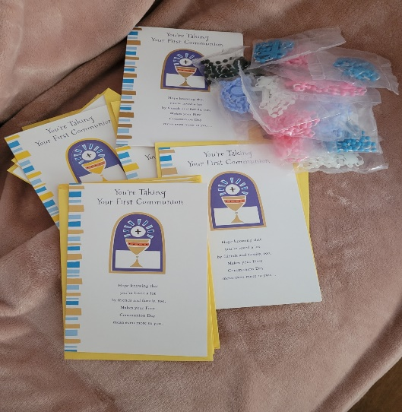
Cards with Rosary beads were purchased for those children making First Communion and Confirmation.

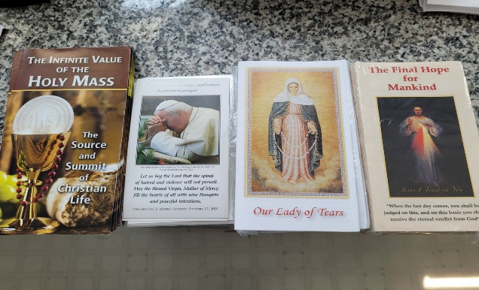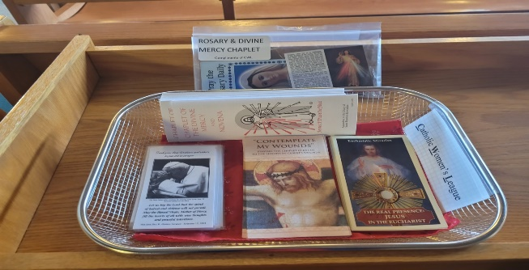
Pamphlets; Rosary/Divine Mercy with Rosary beads donated to our parish to share our Faith. Constantly needs refilling, good sign.
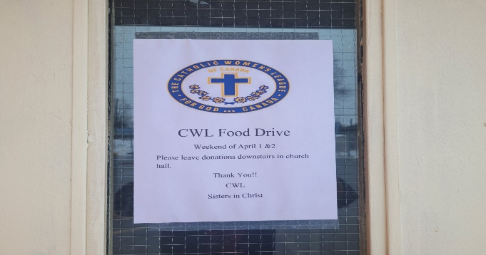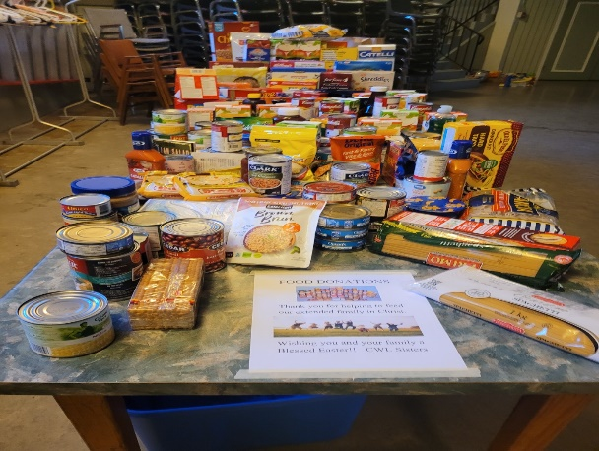
Successful Food Drive, for those in need.
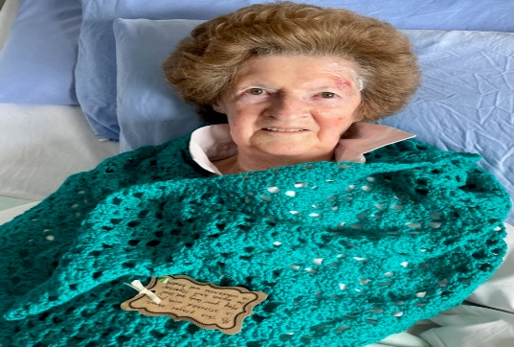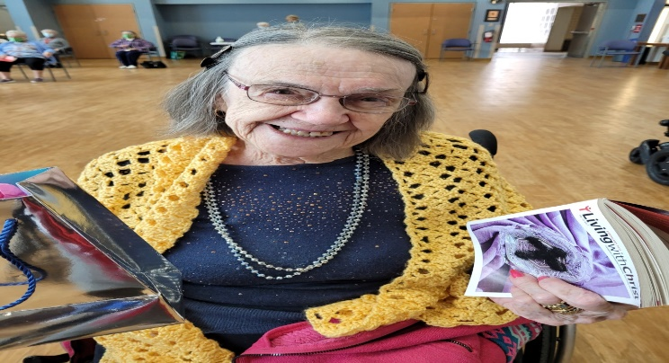
Prayer shawls donated to our CWL sisters in Long Term Care. Spreading the love through sisterhood.
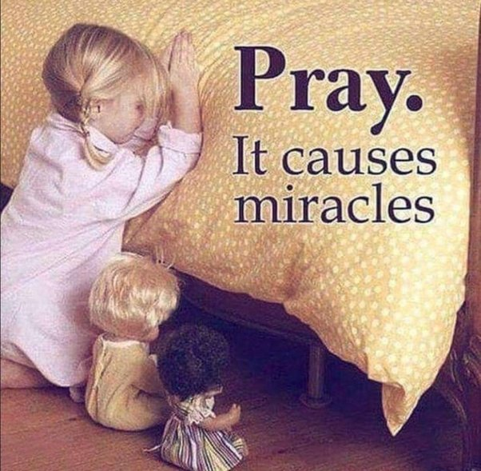
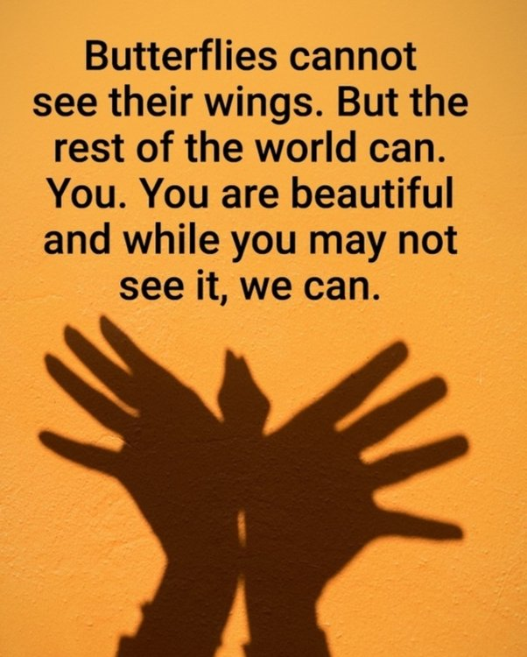
Examples of our COVID emails.

